[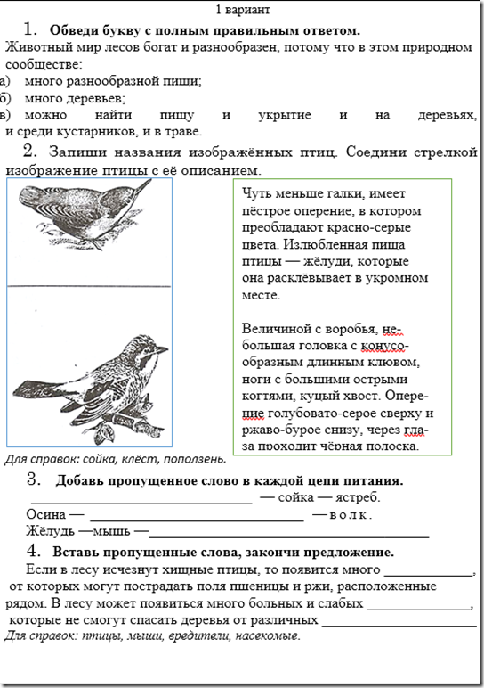](https://uma.by/foxy/wp-content/uploads/sites/2/2018/02/image.png)

[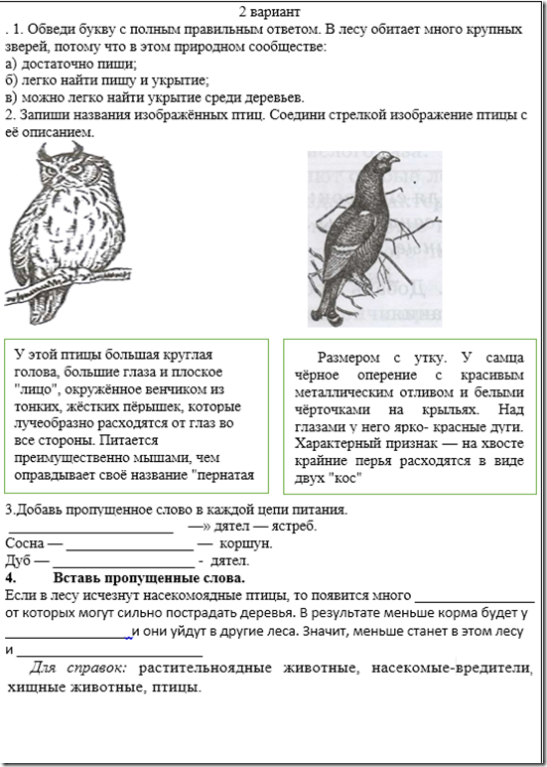](https://uma.by/foxy/wp-content/uploads/sites/2/2018/02/image-1.png)